QNI BLOG

I am currently a CSP student based in North Cluster District Nurses in Oldham. For my empowerment project I chose to concentrate on the public health need pressure ulcer care and prevention. My rationale for this was that pressure ulcers are in the top 10 safety harms in the NHS (Fletcher,2022). They are costly to both the patient and the NHS costing the NHS 3.8 Million daily. They cause immense pain and negatively affect a patients quality of life. When reviewing my service area to see where we could improve I realised that we did not have a repositioning chart for patients within their own home. These are common practice in care homes however for patients in their own home who are arguably more at risk of damage I found there was a lack of guidance and intervention.

OBJECTIVE
The aim of my project was to empower patients and enable them to take ownership of their own pressure relief and ultimately promote patient independence. When patients become unwell as nurses we take over their care and this can result in patients losing control over everyday decisions and can result in them losing their confidence and autonomy. Therefore, the aim of my empowerment project was to give the power back to the patient and involve them in their own repositioning care. My objective was to create a repositioning chart that would act as a communication tool between the patient; their carers, their family and the district nurses.

Before commencing my project I gained a profile from governance of the statistics in Oldham for the occurrence of pressure damage; I wanted to make sure that my intervention was needed. From 01.09.2023 to 01.09.2024 there were 382 pressure ulcers reported in Oldham; of these 330 were category 2 pressure ulcers, 41 category 3 pressure ulcers and 11 category 4 pressure ulcers. I also found that the incidence of pressure ulcers in Oldham was increasing; therefore there was clearly a need for intervention.

Implementation
There were a few steps I had to go through to implement my project. As this was new documentation that I was proposing my initial collaborative partners were the governance team. It was important to ensure that the document would meet legal requirements for the Northern Care Alliance trust. At the beginning I worked quite closely with the governance team to create this document; I had a meeting with both my assessor and the governance lead to discuss my ideas. Prior to this meeting I had created my own repositioning chart; however we did not continue with this one and governance then assisted with creating a new document which could be used in Northen Care Alliance. The governance team then signposted me to the quality improvement team who provided me with guidance on how to successfully implement a new project idea which I found useful.Myself and my assessor then had another meeting with the governance team to agree on the finalised document. The next step was to liaise with the TVN service and the lead nurses to gain their approval to continue. Following this I attended a QPEC Meeting which is a meeting where all new documents are presented across the NCA and approved for final implementation.
Overall the whole process of creating a document and ensuring it met legal requirements was quite lengthy. I found it very interesting and I feel it has developed my understanding of the process involved in trailing new ideas and I also feel I have developed my understanding of the role of governance. Finally my finished product was a re-positioning chart that aimed to act as a communication tool between the patient, carers, unpaid carers and the district nurses.
Following the success of my empowerment project I am now very proud that my document has now been rolled out across all the district nursing teams in Oldham to use. I have had feedback from the practice facilitator that following an investigation into pressure damage they feel that my repositioning chart would have been beneficial in reducing harm to a patient . Going forward I am hopeful that my idea will help to reduce patient harm and ultimately improve patient care.
Tara Tomassi
Community Nursing Specialist Practitioner apprentice at Manchester Metropolitan University
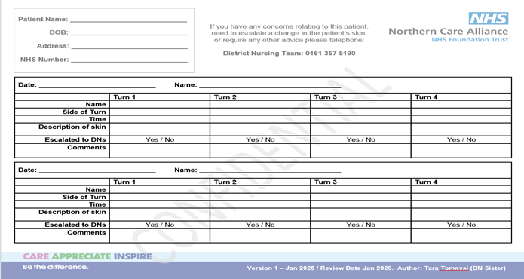
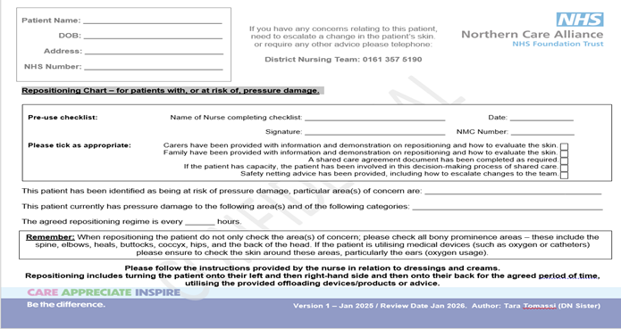
(repositioning chart T.Tomassi 2025)

