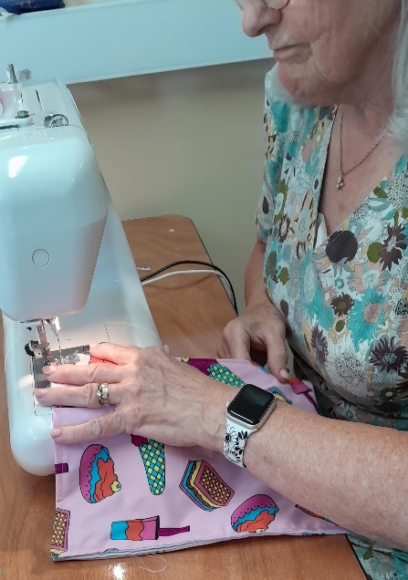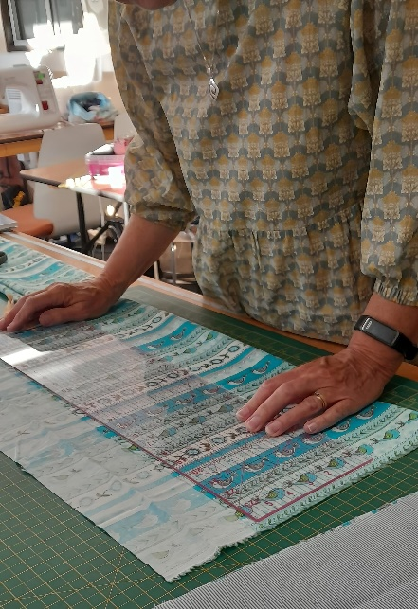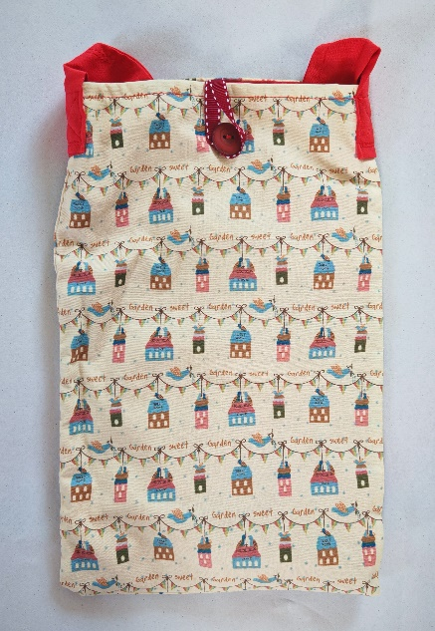

Thread Forward: Stitching Together Compassion, Community, and Sustainability
In a quiet corner of our community, a simple yet powerful movement is threading lives together, one stitch at a time. Thread Forward is an empowerment project rooted in compassion, collaboration, and environmental awareness. It brings together local sewists, patients, families, and healthcare professionals to meet a very real need: creating handmade syringe driver bags for patients receiving end-of-life care at home or in healthcare settings. But this isn’t just about sewing bags. It’s about creating dignity, connection, and environmental responsibility, woven into each piece.

A Local Solution to a Growing Need
Syringe drivers are small infusion pumps used to deliver medication, often used in palliative care. Yet in many areas, there is a lack of appropriate, patient-friendly bags to hold them securely. Thread Forward was born to meet this gap. The project invites local people to donate unused textiles and fabric, which are then repurposed by local sewists (individuals or groups) into custom-made, functional syringe driver bags.
These bags are then distributed by district nurses directly to patients, providing a practical tool that helps maintain mobility, protects medication from sunlight, and reduces unplanned nurse callouts for technical issues. Most importantly, the bags offer a de-medicalised, personalised touch that often brightens what can be a difficult time for patients, their loved ones and carers.
Inspired by Environment, Powered by Community
The inspiration for Thread Forward began with a different kind of observation: the growing concern of textile waste and visible recycling issues in the local area. With textile landfill contributing heavily to CO₂ emissions, the project also addresses an urgent environmental need. To date, Thread Forward has saved over 100 square metres of fabric from landfill which is a meaningful step toward cleaner air and reduced respiratory illness in our community.
By connecting the dots between healthcare and sustainability, Thread Forward supports the NHS Long Term Plan and contributes to greener nursing practices. It proves that small, local actions can have wide-reaching benefits to not only reduce waste, but to directly impact patient care and enhance care quality.
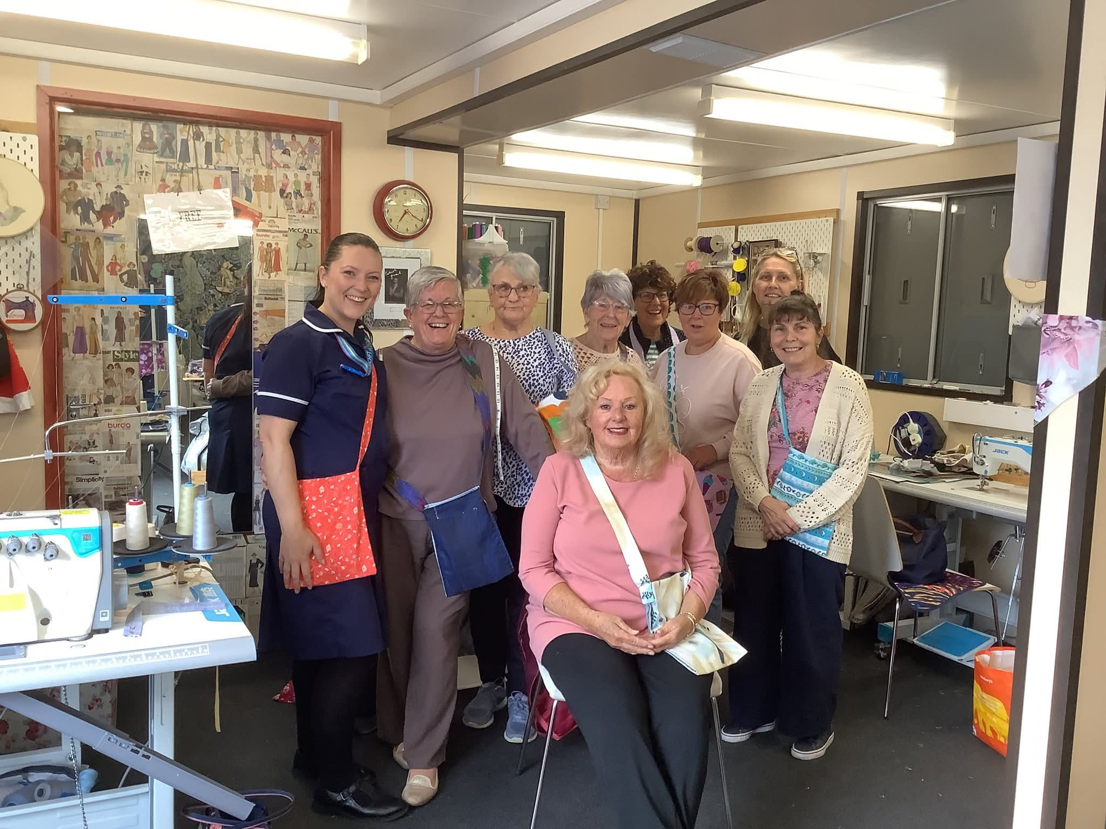

More Than a Bag. Stories That Matter!
The true heart of Thread Forward lies in the stories it helps create.
One family, upon receiving a syringe driver bag, was reminded of their loved one’s passion for sewing. She had once made theatre and dance costumes by hand for her children and grandchildren which prompted conversations of happy past times. The bag brought a comforting, happy memories into a time of grief for the whole family.
A care worker, concerned about the risks of dropping syringe drivers when mobilising patients or providing hygiene care, learned to sew the bags herself, turning her concern into empowerment.
Another patient in a care home became very popular because of the bold, creative design of his bag. His joy and pride because of this brightening the spirits of staff and residents alike but also brought him visitors and happy conversations. This gentleman stated that no one had ever given him a gift before and stated he felt very loved and supported from the nurses and felt like a whole community project team were supporting him.
These are not just bags…they’re conversation starters, memory holders, and dignity protectors. Free to the patient and kept as tokens by family and loved ones.

A Movement with Momentum
What began as a simple idea has grown into a connected, collaborative network. The local sewist community, often working in isolation, has come together through Thread Forward, forming friendships, support networks, and a shared purpose.
Using my established Recycle and Reuse social media group, the project has recruited and supported participants who are passionate about sustainability and community wellbeing. A freely accessible online PDF syringe driver bag sewing guide has been created, along with a QR code that links users to all relevant information and instructions, making it easy for anyone to join in, from seasoned seamstresses to complete beginners.

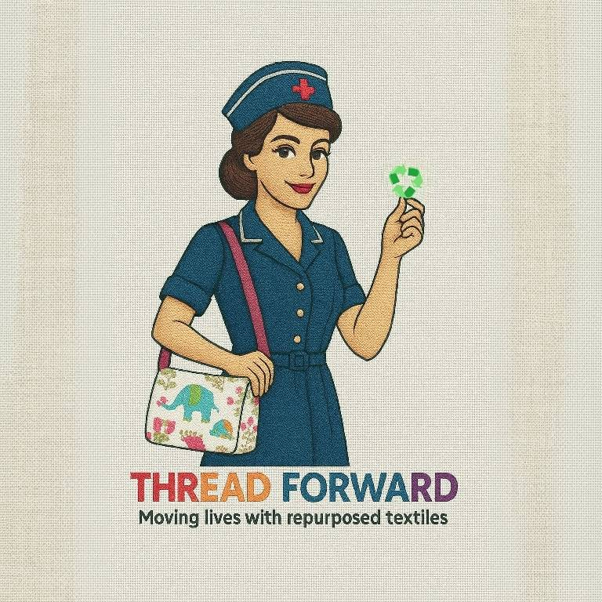

Stitching the Future Together
Thread Forward is proof that grassroots projects, driven by empathy and purpose, can make a real difference to communities. It empowers individuals, strengthens community ties, honours patients’ lives, and helps protect our planet.
Whether you’re a sewist, a donor, a healthcare professional, or simply someone who believes in thoughtful change, there’s a place for you in this project.
Together, we’re not just sewing bags. We’re threading forward towards a more compassionate, connected, and sustainable future in delivering quality care to those we serve in the community.
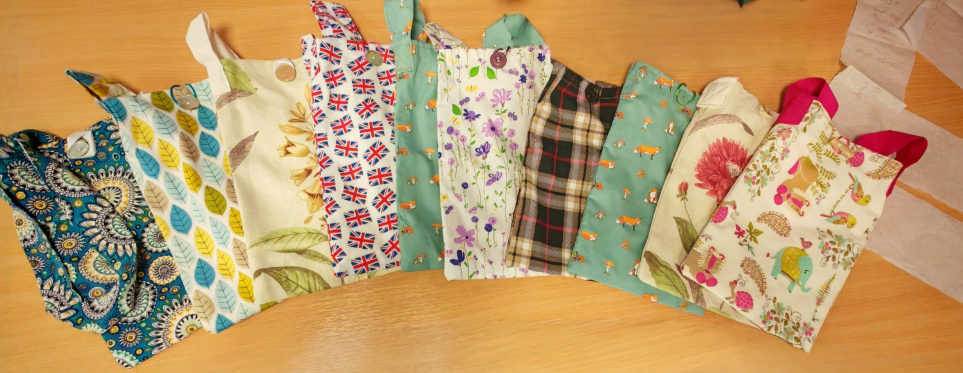

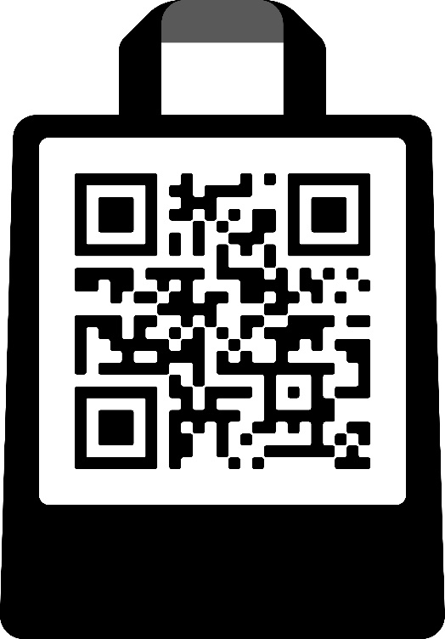
Contact and resource QR

