  Who we are
  We work with people who have a learning disability (and/or autistic people) aged 14 years+.
  If you would like to make a referral to your local Health Facilitation Team or have a question about what support can be offered please contact your local Integrated Care Board or Local Authority.
  
  Health Facilitation contact information
  You can contact your local Health Facilitation Team on the details below:
  Phone: 01273 123456
  Email: hft@nhsxxxxxxx.net
  Online: www.nhs.uk/local/referralform
  or zoom in to your area on the interactive map via the link below
  https://www.learningdisabilityservice-leeds.nhs.uk/get-checked-out/resources/local-team/
  https://www.england.nhs.uk/learning-disabilities
  https://www.mencap.org.uk
  Health Facilitation or
  Primary Care Liaison in learning disabilities
  

Table of Contents  Useful Resources 1  Your local Health Facilitation Team can assist with……………………2-3  Background information 4  How teams work 4  Who we work with 5  Who we work with and how to contact us…………………………….. 6 |  |  | Health Facilitation or Primary care liaison staff  work with many people including:  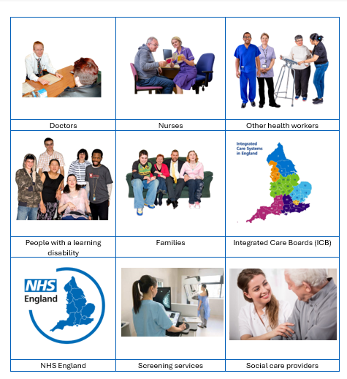
 |  |  | 5

The teams can be funded by local authorities, ICB/Primary Care, Mental Health Commissioners, or others.  This means they may work differently.  For example, some teams:  - also support non-LD autistic people  - have clinical case loads  - work strategically  - work with or are part of Community Learning Disability Teams  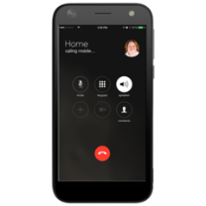  Call us on 01234 567890  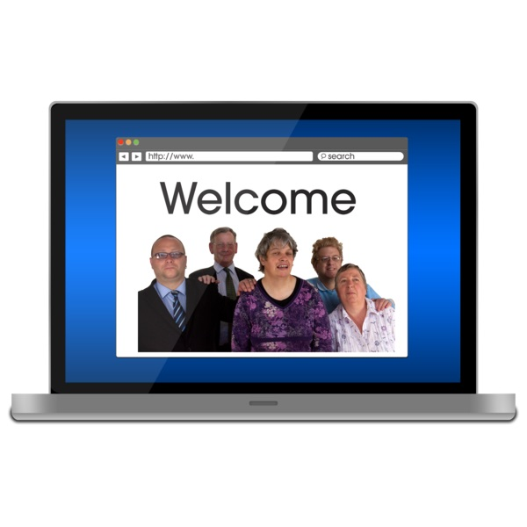    Visit our website at www.hft.com  Email us at email@hft.nhs.net |  |  | Useful Resources  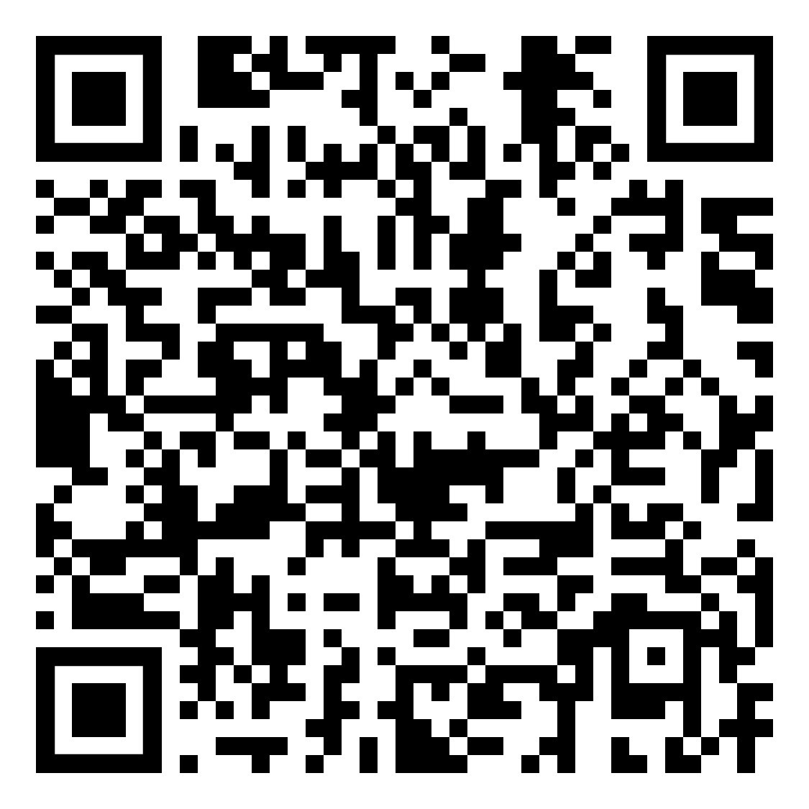  LeDeR national easy read report  Learning from lives and deaths (LeDeR) of people with a learning disability and autistic people  NHS-LeDeR-2022-2023-V12.pdf  Learning Disability Register  Mencap information (including easy read) on how to be added to the register.  https://www.mencap.org.uk/easyread/join-the-learning-disability-register    Annual Health Checks  Annual health checks help to detect and manage health conditions early, review current treatments and medication and to help build continuity of care. https://www.youtube.com/watch?v=ocU8XhD1kh8  There are many other videos to watch    Your Annual Health Check - what it is and why it is important video  Getting Ready For Your Annual Health Check  Please ask your GP practice for a pre-annual health check list.
4 |  |  | 1

Your local Health Facilitation or Primary care liaison may help with:  Providing learning disability awareness training and other health promotion training.  Providing advice on reasonable adjustments.  Make sure the health needs of people with a learning disability are included on local Health planning meetings.  Make sure that national screening programmes consider the needs of people with a learning disability.  Developing pathways with health services that meet the needs of people with a learning disability.  Providing training and support to GPs and practice staff.  Provide sessions for people with a learning disability on health needs and screening.  Increase the uptake of the learning disability Annual Health Check.  Supporting general practices to establish and maintain a Learning Disability Register.  Advising on missed health appointments.  Promoting and sharing useful resources e.g. a Hospital Passport easy read information. |  |  |   STOMP/STAMP - Supporting the reduction of psychotropic medications prescribed to people with learning disabilities (and autistic people). Easy read and other resources are available on this page.  https://www.england.nhs.uk/learning-disabilities/improving-health/stomp-stamp/    Ask Listen Do - resources and advice into how providers support people with a learning disability, autism, or both, and their families and carers, to provide feedback on services and to raise a concern or complaint. Links to easy read and other resources are available on this page. https://www.england.nhs.uk/learning-disabilities/about/ask-listen-do/  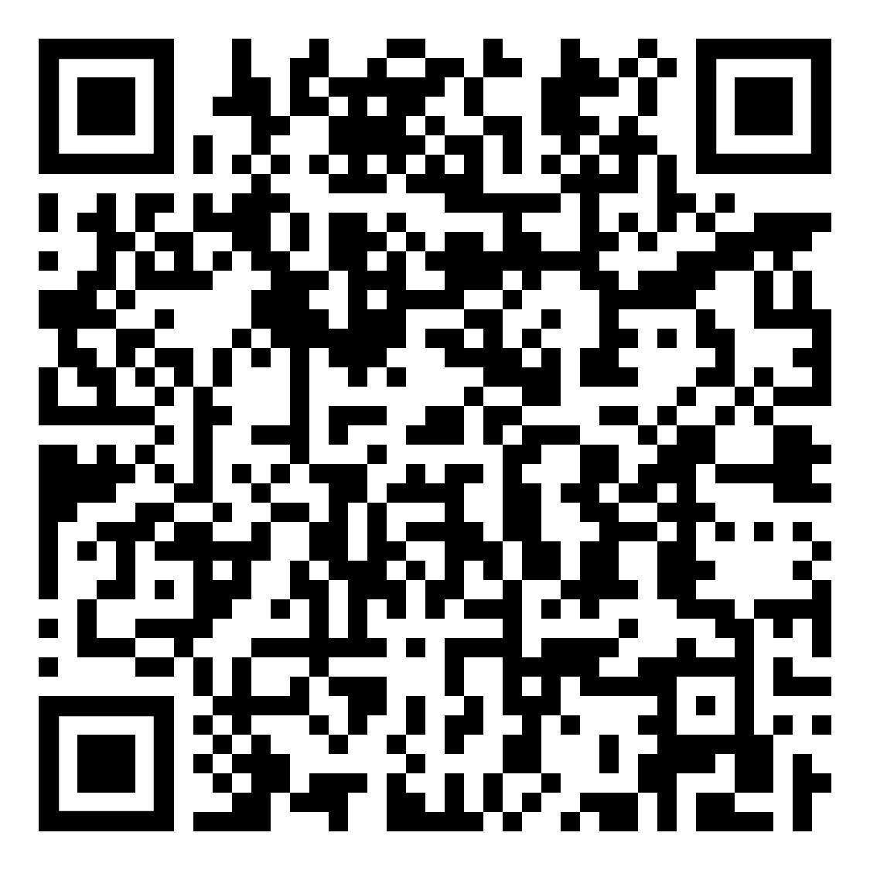    Supporting people with a learning disability and autistic people to leave hospital in a timely manner. Contact your complex needs team or acute liaison team https://www.england.nhs.uk/publication/five-key-elements-for-discharge-supporting-people-with-a-learning-disability-and-autistic-people-to-leave-hospital/  Supporting GP practices to be more learning disability friendly.  https://www.england.nhs.uk/wp-content/uploads/2017/09/how-to-support-people-with-learning-disabilities.pdf
2 |  |  | 3

